Interval Activity Scheduling Algorithm
Introduction:
The objective of this final project was to help solve a hypothetical problem we are facing. This issue we face is that we have is a client who owns a gym similar to the YMCA, this gym has many rooms to be filled with scheduled activities. The client is currently choosing the activities by hand and it is time consuimg for them because they have so many rooms to fill with the max amount of activities. The objective of our program is to find solutions to the interval activity scheduling situation for our hypotheical client. The client would need to provide us with files for each room with the activities listed in each file. The activities in the file have names, start times, and end times. Our program will take this file as input, create an object for each event with attributes: name, start time, and end time. Start time and end time are objects of the time class. We store the event objects in an array. We then run our algorithm to find the solution. With a program to find the optimal solution of scheduled activities it would help the client save time and therefore money. It would also guarantee them to have an optimal solution everytime by reducing the risk of human error.
The background knowlege we have on this algorithm is from what we learned during lecture in class. We went over this algorithm in a greedy implementation and an optimal implementation. The lecture notes went through examples and we spent a bit of time discussing examples and solutions to the problem. These examples and discussions gave us enough information to implement the greedy and optimal algorithm we went over in class.
Algorithm:
The greedy implementation of the algorithm starts with the array of event objects created upon the read in of the input text file. We first sort by start time using insertion sort with the function swapEvents(array, indexA, indexB) to swap the elements of the array. Once this is in order of start time we choose the first event. We then run a function to eliminate the events that conflict with the start/end time interval of the first event. If an event is a conflict with the chosen event we change the name attribute of this event object to “Conflict”. This way the algorithm knows to not consider this as a part of the solution. We then repeat the algorithm by choosing the first event that does not have a conflict with the previous. We repeat this process of choosing an event and eliminating the conflicts until all of the events considered and the solution is written to a file.
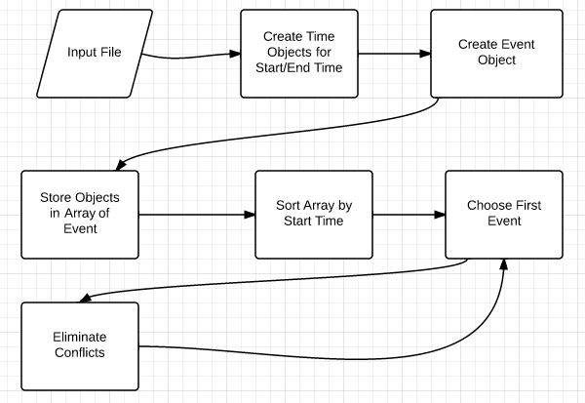
Figure 1: A flowchart of the logic for the greedy implementation

As show in figure 2 two the optimal algorithm is executed the same as the greedy algorithm but instead of sorting by start time we sort by end time.

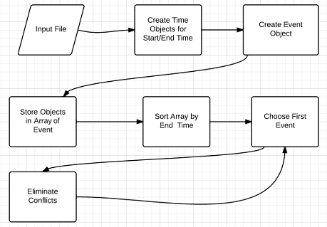
Figure 2: Flowchart of optimal algorithm for interval event scheduling.
The time complexity of the greedy and optimal algorithm can depend a lot on the way the data is sorted. Because of this we are considering the actual sorting algorithm used as a preprocessing step to do before running the algorithm. The asymptotic analysis for insertion sort is as follows:
Best Case: O(n) is in already sorted.
Worst Case: O(n^2) when the data in opposite order.
For the algorithm minus the sorting we can use pseudo code to help break down the code using pseudo code in figure 3.

Sort events by start/finish times so that f1 ≤ f2 ≤ ... ≤ fn.
A ← φ
for e = 1 to n {
if (event e compatible with A) {
A ← A ∪ {e}
}
}
return A
Figure 3: Pseudo code for interval scheduling algorithm.

The first for loop runs through the elements n times which has run time of O(n). Then we have to check if the event is a conflict, this if statement has a run time of O(logn). The running time of the entire algorithm is O(nlogn). The empirical times of the algorithm range from machine to machine and depend largely on the kind of machine the code is running on and is therefore not a good way to evaluate an algorithm. We represent the time complexity of our algorithm O(nlogn) following the asymptotic analysis of the algorithm.
Test Cases:
The problem is described in the introduction and in short our objective is to find an optimal solution for interval activity/event scheduling. The input is a list of activites and the output is a list of activities to be scheduled without conflicts.
In order for our algorithm to work we need an input text file. This text file contains the room number to be scheduled and a list of activities/events. Each event has a name, start time, and end time. To begin the algorithm the process run before the final set of events is chosen, is a sorting algorithm. If the file was already sorted before submitting to our program it would run faster because the preprocessing of sorting the data would be taken out of steps.
As shown in figure 4, the output for the test cases show the differences between the greedy and optimal algorithm as you can see the different events they had for the final set but ended up with the same amount of events. We validated all of the outputs to be correct by hand.
TestCase1  File for testing Final Project  5  Spinning 8 00 9 00  Dodge_ball 10 30 12 30  Yoga 7 30 8 30  Boxing 15 30 16 30  Boot_camp 11 00 12 00 | Greedy:  Yoga 7:30 8:30  Dodge_ball 10:30 12:30  Boxing 15:30 16:30  Number of Events: 3 | Optimal:  Yoga 7:30 8:30  Boot_camp 11:00 12:00  Boxing 15:30 16:30  Number of Events: 3
TestCase2  File for testing Final Project  10  Spinning 8 00 9 00  Dodge_ball 10 30 12 30  Yoga 7 30 8 30  Boxing 15 30 16 30  Boot_camp 11 00 12 00  Martial_Arts 17 00 20 00  Basket_Ball 7 00 13 00  Racquet_Ball 10 00 14 00  Weight_Training 18 30 20 30  Aerobics 9 30 13 30 | Greedy:  Basket_Ball 7:00 13:00  Boxing 15:30 16:30  Martial_Arts 17:00 20:00  Number of Events: 3 | Optimal:  Yoga 7:30 8:30  Boot_camp 11:00 12:00  Boxing 15:30 16:30  Martial_Arts 17:00 20:00  Number of Events: 4
TestCase3  File for testing Final Project  20  Spinning 4 00 23 00  Dodge_ball 10 30 12 30  Yoga 7 30 8 30  Boxing 15 30 16 30  Boot_camp 11 00 12 00  Martial_Arts 17 00 20 00  Basket_Ball 7 00 13 00  Racquet_Ball 10 00 14 00  Weight_Training 18 30 20 30  Aerobics 9 30 13 30  Water_Aerobics 6 00 8 00  Hot_Yoga 7 00 10 00  Jump_Rope 13 00 15 00  Karate 22 00 23 00  Seam_Carving 10 00 10 30  Foot_Skills 9 30 10 30  Zumba 5 00 6 30  Dance_Aerobics 12 00 1 00  Core_Exercises 13 30 14 00  Arm_Sculpting 14 00 14 30 | Greedy:  Spinning 4:00 23:00  Number of Events: 1 | Optimal:  Dance_Aerobics 12:00 1:00  Zumba 5:00 6:30  Yoga 7:30 8:30  Seam_Carving 10:00 10:30  Boot_camp 11:00 12:00  Core_Exercises 13:30 14:00  Arm_Sculpting 14:00 14:30  Boxing 15:30 16:30  Martial_Arts 17:00 20:00  Karate 22:00 23:00  Number of Events: 10
Figure 4: Test case input and results. Column 1 shows the input and column 2 and 3 show the output.
Discussion:
There have been many opportunities for growth and improvement for us as developers throughout the semester. This final project was no different in allowing us the opportunity to improve. The first lesson being that organization can slow the production of a program at first but in the long run it makes it more flexible and easier to adapt and debug. Since we broke everything into their own class files and used object oriented theory throughout development we were able to better implement the logic behind our algorithms. This organization is also a key for helping others to understand our code. Another lesson we learned is that our program can be limited by which sorting algorithm we decided use. The efficiency of preprocessing the data impacts the efficiency of the entire program so it was important for us to consider this when writing our code. Along the same lines the data structures we choose can also affect efficiency. For example, in our program we decided to use an array to store events instead of a vector. This made it so that we had to mark things as a conflict instead of just deleting that part of an array. The static size of the array made us have to change our logic so we could accomodate the limitations of the data structure. One final limitation of our project was adding in the weighted events. This is easy to consider in theory but much harder to implement in code in such a short amount of time.
Conclusion:
Overall this project was a success. We were able to achieve our objective of inputing a file with a list of intervaled events and output a list of events that give us the max events of the set. We implemented two different algorithms to achieve this goal: one greedy algorithm, and the other an optimal algorithm. The optimal algorithm is reccommended for use in real life but we implemented the greedy algorithm to show the differences. We learned a few lessons about organization and data structures along the way to creating our now efficient and working program.

